

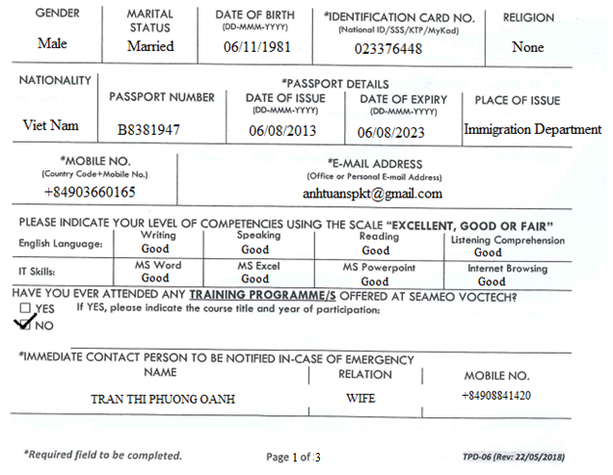

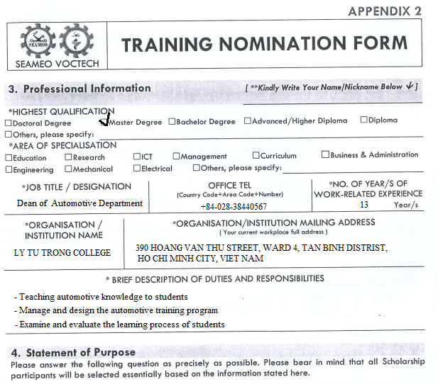
When I participate this training I think I will develop the theoretical and practical knowledge which I need to upgrade my skills. Consider course that have a practical component, so I can actively practice the newly acquired skill. This will help my training effcective.
Beside that, I thinks I have a lot of benefit when I join this training such as:
- Updating new Automobile technology knowledge
- Exchange and learn from local and international colleagues
- Exchanging and refining the automotive training program for my college
- Learn research-based strategic learning and teaching practices.
- Practice practical classroom strategies you can use in your classroom



